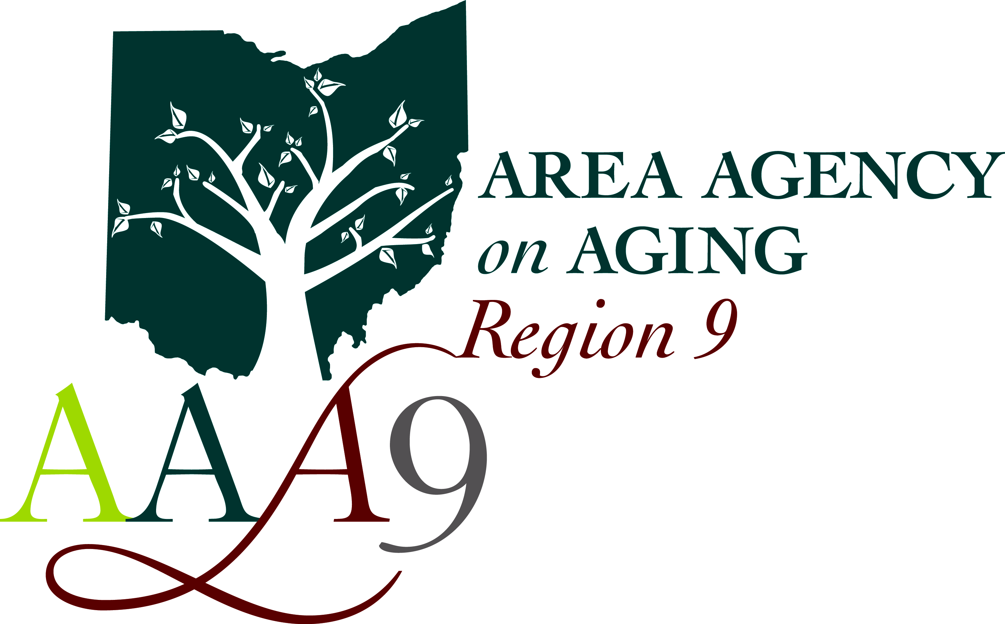 | Area Agency on Aging - Region 9, Inc.  710 Wheeling Avenue, Cambridge, Ohio 43725 Voice (800)945–4250 ♦ Fax (740)439-0064  Serving Ohio’s Belmont, Carroll, Coshocton, Guernsey, Harrison, Holmes, Jefferson, Muskingum, and Tuscarawas counties for over 40 years

PASSPORT Case Management Internship

Non-paid on-site position

Area Agency on Aging is a Non-profit Organization that assists our community by providing resources, provider management, and case management especially among the aging and disabled. We are looking for an individual with a desire and compassion to assist with the elderly population.

Potential list of Responsibilities:
- Assist with assessment of consumer
- Aid with determining consumer’s needs, strengths, and circumstances
- Assisting with coordinating services and interventions needed for the consumer’s care
- Help with monitoring the delivery of all services identified on service plan
- Assistance with re-evaluations of the consumers goals and objectives for long-term care services, determination of program eligibility, authorizations of the amount, scope, and duration of long-term care services.
- Assisting the consumers to connect with needed Medicaid-waiver services and other medical and social services.
- Other responsibilities may be given upon Internship

Requirements:
- Must be pursuing a degree in Social Work or Nursing
- Have own transportation.
- Have own cell phone and willing to download Authenticator app
- Have a passion for community service and working with people
- To be self-motivated and goal oriented
- Technology savvy
- Problem solving and prioritizing skills

