Summer Crisis Program July 1- September 31, 2021

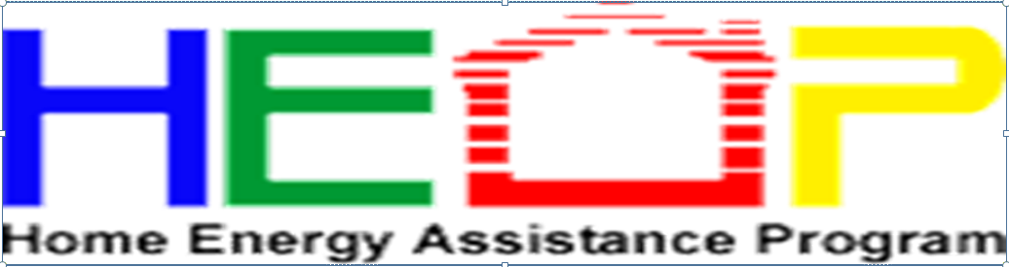

The 2021 Summer Crisis Program (SCP) will provide eligible households with a one-time benefit to assist with electric utility bills, central air conditioning repairs, and air conditioning unit and/or fan purchases. Household income must be at or below 175% of the Federal Poverty Guidelines and household’s must have at least one additional eligibility criteria listed below:

• A household member who is age 60 or older.

• A household member has a documented medical condition verified by a licensed medical professional who is qualified under Ohio law to write prescriptions.

• A household member that was diagnosed with COVID-19 in the last 12 months. May provide a written statement as proof of medical diagnosis.

• Percentage of Income Payment Plan Plus (PIPP) customers are eligible for assistance towards their default PIPP payment, first PIPP payment, central air conditioning repairs, or may receive an air conditioning unit and/or fan.

• A household’s electric utility has a disconnect notice, has been shut off, or new electric service is being established for the household. These households may also receive an air conditioning unit and/or fan or central air conditioning repairs if the household can maintain electric service for 30 days.

This year the program will be open July 1 – September 30, 2021. The maximum benefit amounts for the 2021 program are: $500 for customers of regulated utilities and $800 for customers of unregulated utilities (municipal utilities or cooperatives). Air conditioning units and/or fans may only be provided to eligible customers who have not received an air conditioning unit or fan in the last three years.

New this year: The utility assistance benefit is separate from the additional benefit. Households may receive the maximum utility assistance benefit towards their electric bill and still receive an additional benefit (i.e., central air conditioner repair, air conditioner unit, and/or fan).

SCP appointments should be scheduled with the local energy assistance provider.

You can contact Area Agency on Aging 1-800-945-4250 or your county Community Action Committee for more information.

|  |  |  |
| --- | --- | --- |
| Belmont | Community Action Commission of Belmont County | 740-695-0293 |
| Carroll | Harcatus Tri-County Community Action Organization | 855-806-8650 |
| Coshocton | Kno-Ho-Co-Ashland Community Action Commission | 740-622-9801 |
| Guernsey | G-M-N Tri-County Community Action Committee | 844-320-3206 |
| Harrison | Harcatus Tri-County Community Action Organization | 855-806-9650 |
| Holmes | Kno-Ho-Co-Ashland Community Action Commission | 330-674-6479 |
| Jefferson | Jefferson County Community Action Council | 844-493-1195 |
| Muskingum | Muskingum Economic Opportunity Action Group, Inc. | 844-493-1197 |
| Tuscarawas | Harcatus Tri-County Community Action Organization | 855-806-9650 |
|  |  |  |
|  |  |  |
|  |  |  |
|  |  |  |
|  |  |  |
|  |  |  |
|  |  |  |
|  |  |  |
|  |  |  |