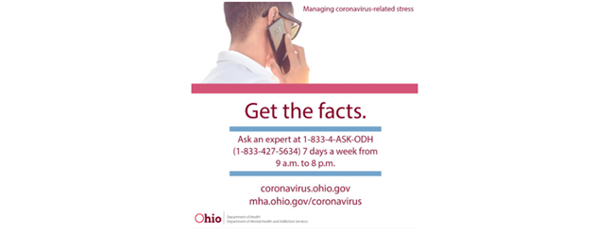

Mental Health I&R line 877-275-6364 (M-F 8AM-8PM)
COVID-19 Stress Line 1-833-427-5634 (7 days a week 9AM-8PM)

