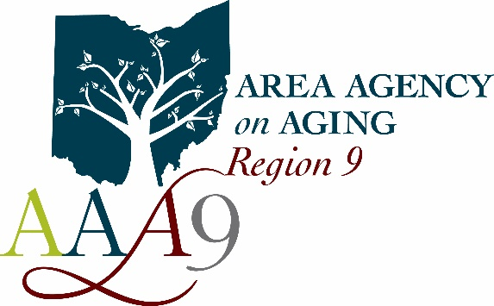 | Area Agency on Aging - Region 9, Inc.  710 Wheeling Ave.  Cambridge, Ohio 43725  Voice (800) 945-4250 ♦ Fax (740) 439-3592  Serving Ohio’s Belmont, Carroll, Coshocton, Guernsey, Harrison, Holmes, Jefferson, Muskingum, and Tuscarawas counties for over 40 years

Dear Provider,

At AAA9, we care about the health and well-being of our community’s older adults. Unfortunately, elder abuse is something that can have an extremely negative impact on these individuals. Elder abuse can come in multiple forms such as emotional, financial, and physical abuse. Due to COVID-19, our older adults are at an increased risk of experiencing elder abuse. This is due to the social isolation measures we are taking to remain healthy. Our seniors are having limited in-person contact therefore, it leaves the signs of abuse less likely to be detected. Though video calls can be helpful in identifying some signs of abuse, video calls are just unfeasible for a significant amount of our elderly population. This is due to limited financial means or limited technological abilities.

COVID-19 has also caused an increase in financial scams. Some individuals have noticed the stock markets and their retirement plummeting causing them to believe in the promises of financial freedom from a scammer. Believing in these scams could have a devastating impact on our consumers.

AAA9 wants to ensure our older adults are getting the resources they need if they are experiencing some type of abuse. Because of this, we will be increasing our services to include assisting with those in situations of abuse, neglect, or exploitation.

If you know of any individual who could use our assistance, please have them call Ashley Bichard at (740) 421-9755.

Thank you,

Ashley Bichard
Contract Compliance Manager

