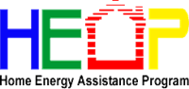
Ohio’s Energy Assistance Programs can help income-eligible Ohioans manage their utility bills. The Home Energy Assistance Program (HEAP) and emergency HEAP provide the benefit directly to a customer’s utility bill. The Percentage of Income Payment Plan (PIPP) is an extended payment plan in which customers pay a percentage of the income toward their utility bill each month.
Help is available for eligible Ohioans trying to cope with the cost of winter heating and summer cooling.
To be eligible for assistance, households must have a gross annual income that is at or below 175 percent of the federal poverty guidelines, have a member in the household who is 60 years of age or older; or have a member who has a medical necessity verified.

For more information or assistance, contact the Area Agency on Aging, Region 9 at 844-932-7277

2019 Total Gross Household Income Guidelines
Household Members 12-Month Income Limit 30-Day Income Limit
150% 175% 150% 175%
1 $18,210.00 $21,245.00 $1,517.50 $1,770.42
2 $24,690.00 $28,805.00 $2,057.50 $2,400.42
3 $31,170.00 $36,365.00 $2,597.50 $3,030.42
4 $37,650.00 $43,925.00 $3,137.50 $3,660.42
5 $44,130.00 $51,485.00 $3,677.50 $4,290.42
6 $50,610.00 $59,045.00 $4,217.50 $4,920.42
7 $57,090.00 $66,605.00 $4,757.50 $5,550.42
8 $63,570.00 $74,165.00 $5,297.50 $6,180.42
When determining 150% of the FPG, households with more than eight members must add $6,480 to the yearly income or $540 to the 30-day income for each additional member. When determining 175% of the FPG, households with more than eight members must add $7,560 to the yearly income or $630 to the 30-day income for each additional member.

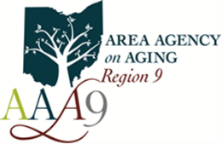

844-932-727

